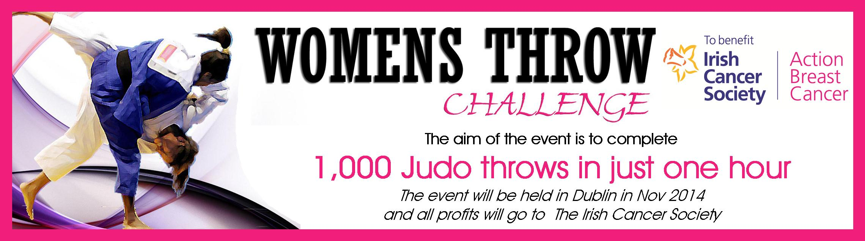

Calling all female judokas, we are about to embark on the largest fundraising event ever attempted in Irish judo history and we need your help.
Our challenge to you comes in two levels.
Level 1 is to complete 1000 judo throws in just hour (collectively in groups)
Level 2 is to complete as many judo throws in one hour (again collectively in groups).
The current recorded record is 2464 throws completed in one hour.

So, if you are an active competitive judo player, leisure & pleasure player, a yellow or black belt there is a level to suit. If you are an ex judo player just looking for reason to return to judo then this is the excuse you need. If you are a male judoka that would like to dawn a pink wig and take part, then this is for you also. No reasonable offer of help will be refused.

Why we are doing this challenge:

- About Breast Cancer: Breast cancer is the most common cancer in women in Ireland. One in 10 women will be diagnosed with breast cancer over the course of their lifetime. The most recent data from the National Cancer Registry shows that 34,798 people were diagnosed with cancer in 2011 and 2,857 women were diagnosed with breast cancer in 2012. In the last ten years cancer survival rates in Ireland have increased by 30% and early detection is the key to survival.

- The Irish Cancer Society’s Action Breast Cancer (ABC) programme is Ireland’s leading provider of breast cancer information and support. Each year they reach thousands of women who are concerned about breast cancer and breast health. They strive to ensure that everyone affected by breast cancer receives the highest standards of treatment, support and care, and to improve quality of life. They do this in a number of ways:
- The National Cancer Freephone Helpline which is staffed by specialist cancer care nurses who are there to speak to anyone concerned about cancer or who require more information. During 2013, the specialist cancer nurses supported 17,469 callers to the National Cancer Helpline, with 2,508 calls from women with a concern about breast cancer.

- Financial Aid: In 2013, the Society’s financial aid programme provided grants to support cancer patients who are experiencing financial hardship due to their cancer diagnosis. In 2013, the society provided financial aid in excess of €1 million and €248,097.00 was provided to breast cancer patients across the country.

- Nursing Services: Night nurses care for cancer patients across the country in their own home during the last days of their life. During 2013 the Society’s night nurses provided 7,770 nights of care with 522 nights of care provided to breast cancer patients.

As you can see The Irish Cancer Society do fantastic work and we all have the opportunity to help, support and contribute to this very worthy cause.

To get involved all you have to do is email your interest to irishwomensjudo@gmail.com and we will email you back a sponsorship form with your unique registration number.

Date and venue in Dublin will be announced shortly as soon as the scale of support for this amazing event is established.

Don’t Delay – Register today!

Kind Regards
IWJ Support Team

James, Brian and Ellie

